**Link to our Repo**

**Aquatix**

https://bitbucket.org/team5c/hidden-leaf

**Contributions**

* Designed and implemented Hours and Prices web page
* Implemented Role based authentication and Authorization
* Designed the Ticket Booking web pages
* Implemented Ticket Booking - Adding Events to to Cart
* Implemented Ticket Booking - Selecting Additional Facilities
* Implemented Ticket Booking - Checkout and Placing order
* Design Admin Pages

**Screenshot of our Home page:**

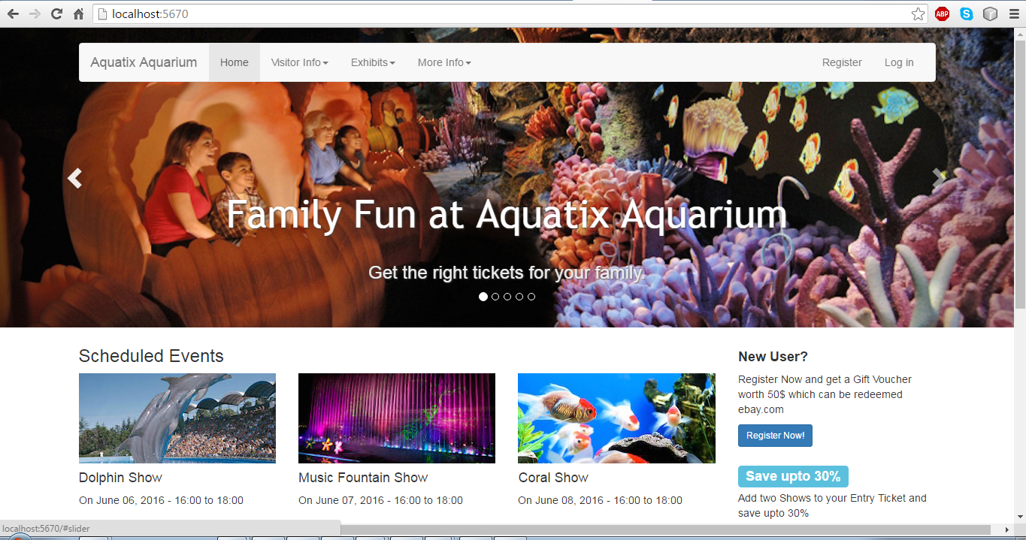

**References**

All the data and images used in our application have been acquired from ***Google images***